**Problem Statement**

* As per 2013 EPA(Environmental Protection Agency) study, an average American wastes about 4.4 lbs of materials per person every day. Majority of the recyclable items are filled in landfills.

* Based on our research, there is no distinct product that can identify all types of recyclable items with appropriate prompts to avoid intermix of trash and recyclable items.

**Objective**

* Efficiently segregate recyclable items from trash to save energy and the environment.



**User requirements/Goals/Constraints**

* Need a device to identify recyclable items and restrict recyclable items to be intermixed with trash.
* Needs to be weather proof and avoid damage from trash inside the container
* Needs to have display panel for friendly usability and buzzer prompting.
* Efficient proximity sensing of recyclable items.
* Scope is limited for home usage- needs further improvements for commercial usage.
* Recyclables should be fed individually to container.

Engineering Design

Process 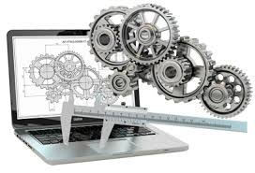

**Ask**:

* Durability of the device, condition of recyclables.
* Too many recyclable items in landfills can lead to pollution.
* Recycling can save a lot of energy.

**Imagine**: We considered 3 solution approaches and shortlisted option - Designed a device to identify recyclable items thrown into a trash bin with a lid.

**Plan**: Design and development work is split into 3 modules - Metal Detector, Motion detector and Display Panel.

**Create**: Implement above 3 modules.

**Test and Evaluate**:

* Performed the unit test for each module separately and captured the test results for the relevant scenarios.

**Improve**:

* In future, the prototype will be enhanced for plastic, cardboard, paper and glass.

**Share Solution**:

* The key strength of the current prototype model is uniqueness of the product to deliver various capabilities like metal detection, LCD display and auto lid open/close.

**Facts **

 Recycling 1 ton of plastic can save an equivalent of 2 peoples energy for 1 year.

 Manufacturing products for recycled paper and plastic reduces water pollution by **35**% and **air** pollution by **73**%.

 One plastic bottle can save enough energy to power a 60 watts light bulb for 6 hours.

 It takes about 25 recycled bottles to make a fleece jacket.

** Facts**

 Recycling 1 ton of plastic can save an equivalent of 2 peoples energy for 1 year.

 Manufacturing products for recycled paper and plastic reduces water pollution by **35**% and **air** pollution by **73**%.

 One plastic bottle can save enough energy to power a 60 watts light bulb for 6 hours.

 It takes about 25 recycled bottles to make a fleece jacket.

** Facts**

 Recycling 1 ton of plastic can save an equivalent of 2 peoples energy for 1 year.

 Manufacturing products for recycled paper and plastic reduces water pollution by **35**% and **air** pollution by **73**%.

 One plastic bottle can save enough energy to power a 60 watts light bulb for 6 hours.

 It takes about 25 recycled bottles to make a fleece jacket.

**School**: Patapsco Middle School

**Grade**: 6th

**State**: Maryland

**Team Name**: The RoboKnights

Team Members

* **Harini Devireddy**
* **Pragna Yalamanchili**
* **Srinidhi Akella**
* **Venya Karri**

**Conclusion **

The device has foundational framework with focused capabilities but has potential to be fully extendable to meet broader diversified needs

Key Advantages

* Minimizes intermixing of recyclable with trash in turn helps
  + Reduction of  chemical toxic gases generation  from Landfills
  + Increased Opportunity on recycling and saves energy

Key Strengths

* Supports metal  detection to avoid intermixing with trash and provides recycle opportunity
* The device is very user friendly - displays a LCD message  and buzzer to prompt user to recycle the item
* If the item is recyclable, the  lid does not automatically open

**Recommendations** 

Consider below capabilities for future enhancements for multi iteration releases for full blown product

* Plastic, cardboard, paper and glass sensing are must have capabilities
* Notification to user’s phone with recyclable data is nice to have future
* Extend product capabilities from residential to commercial usage.



Process flow Diagram

N

Recyclable?

Object in Range

Lid Close

Lid Open

LCD Message Please Recycle

Is timer > 4 sec ?

End

N

Start

Y

Y

LCD Display: Date/Temperature

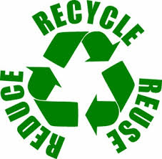 

**Input Devices**

**Ultrasonic Sensor Inductive Proximity Sensor RTC/Temperature Sensor** 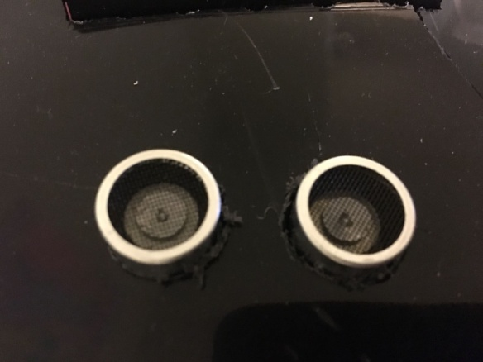 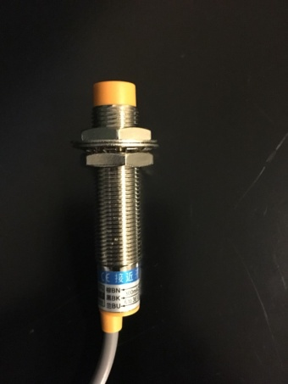 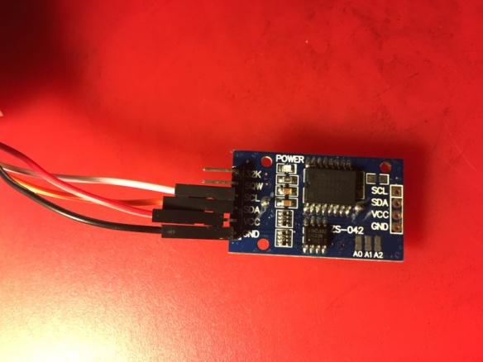



**Output Devices**

**LCD Piezo Buzzer DC-Servo** 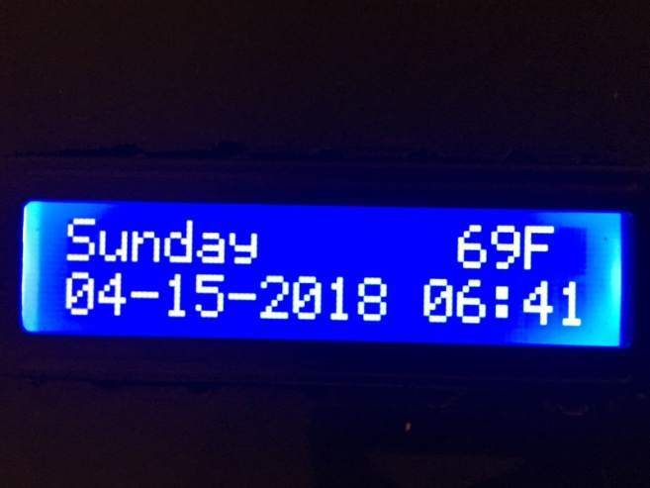 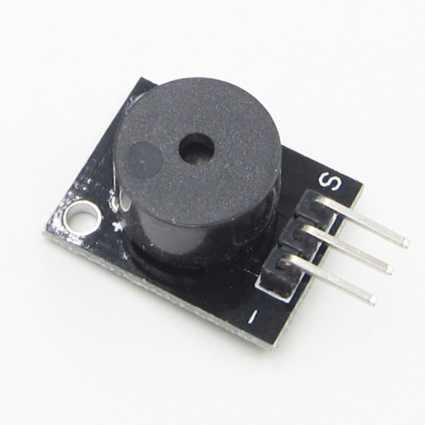 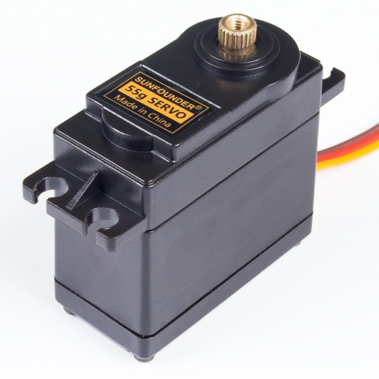

**Papspcp**

Patpsco.png  



**R3 Prototype**

**Front View Top View**  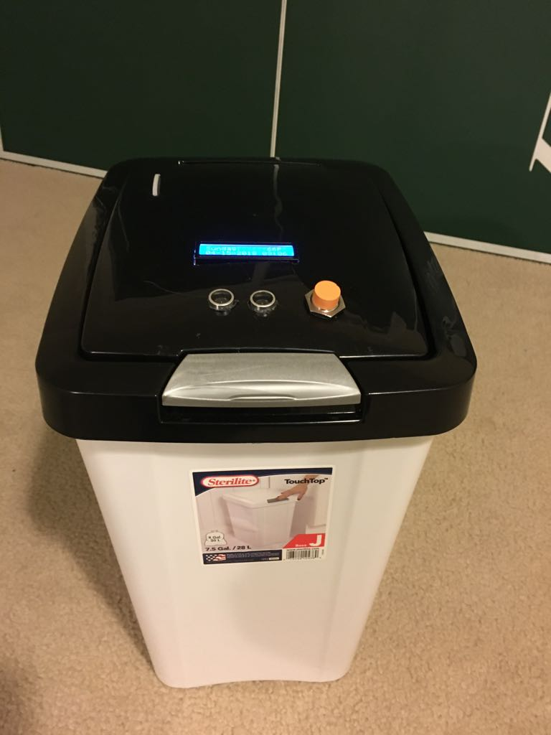 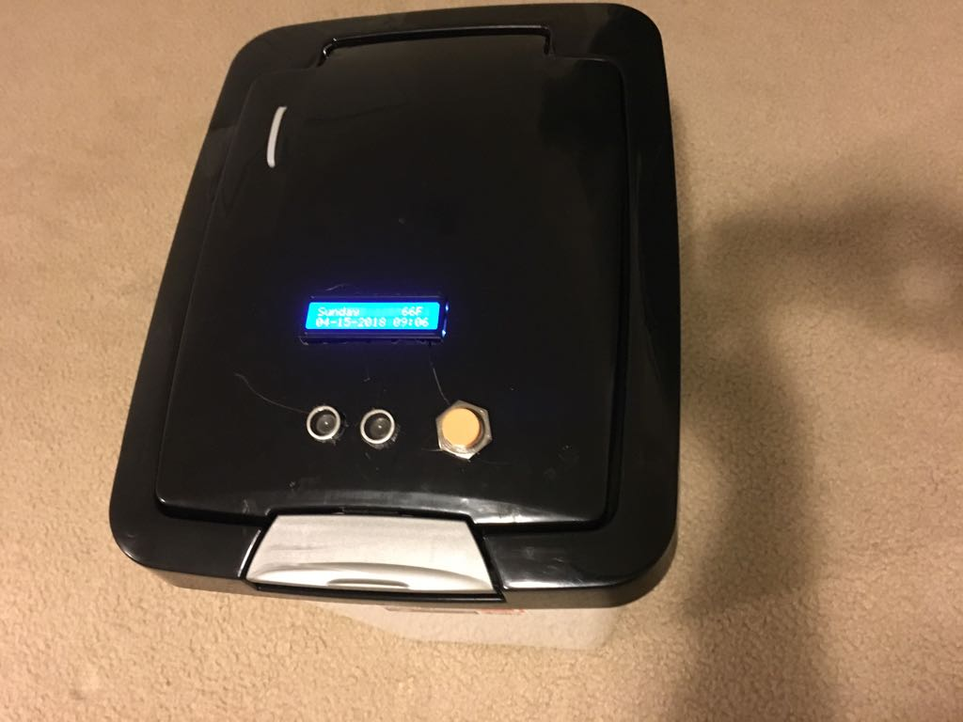

**R3 Prototype**

**Open View Integrated Device Box**  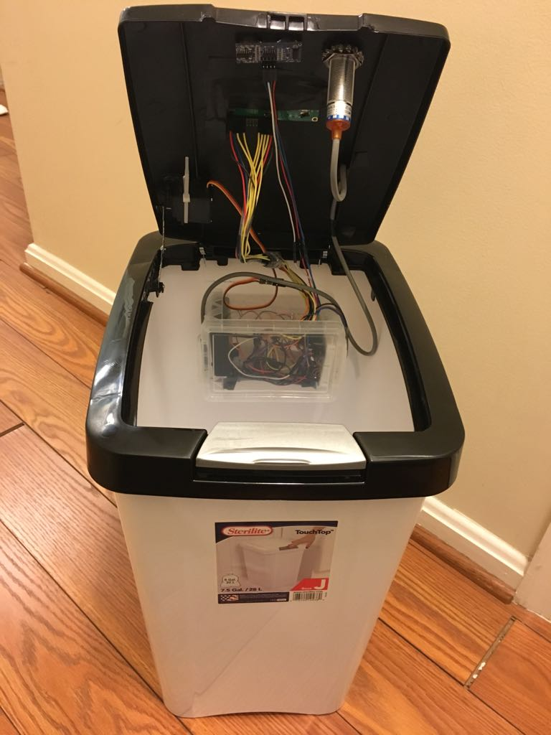 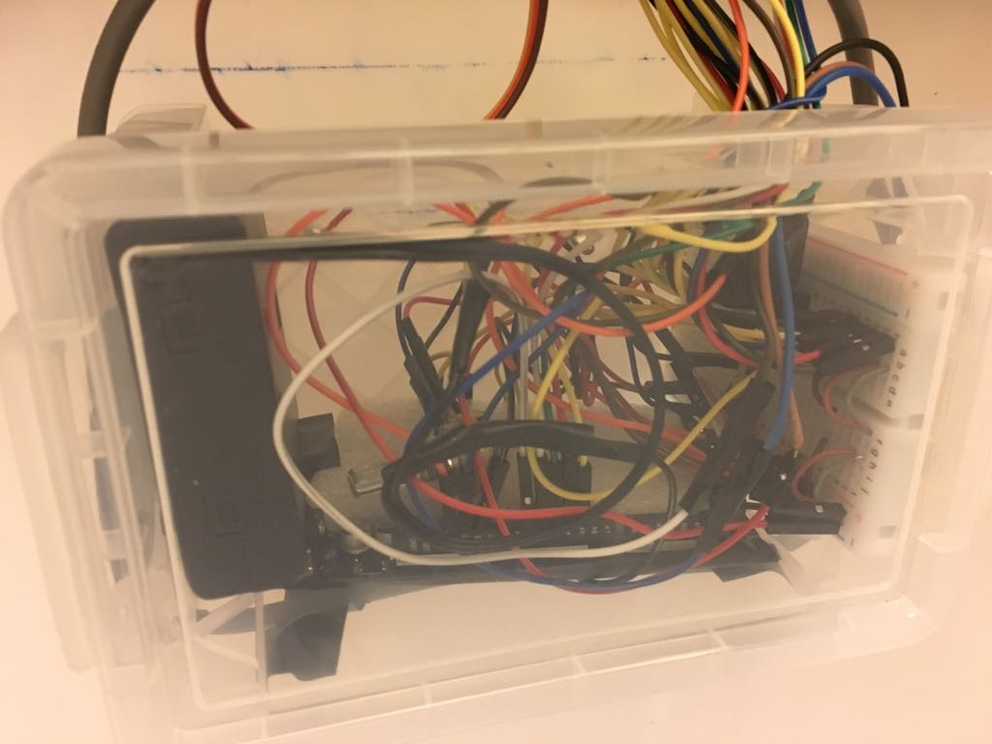



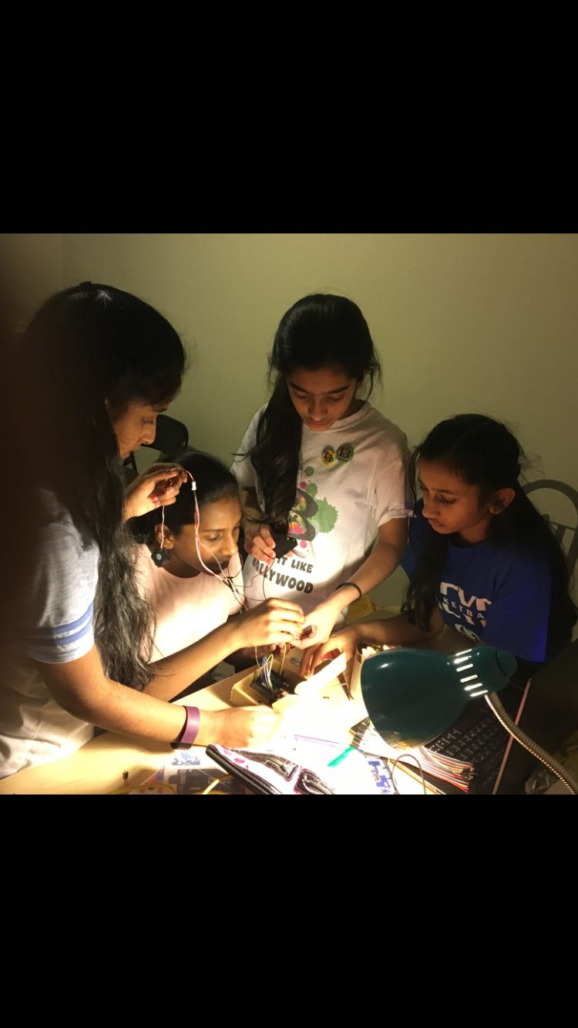

**Arduino Mega**

**Board 2560**

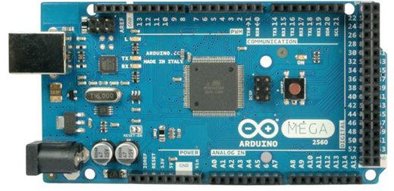



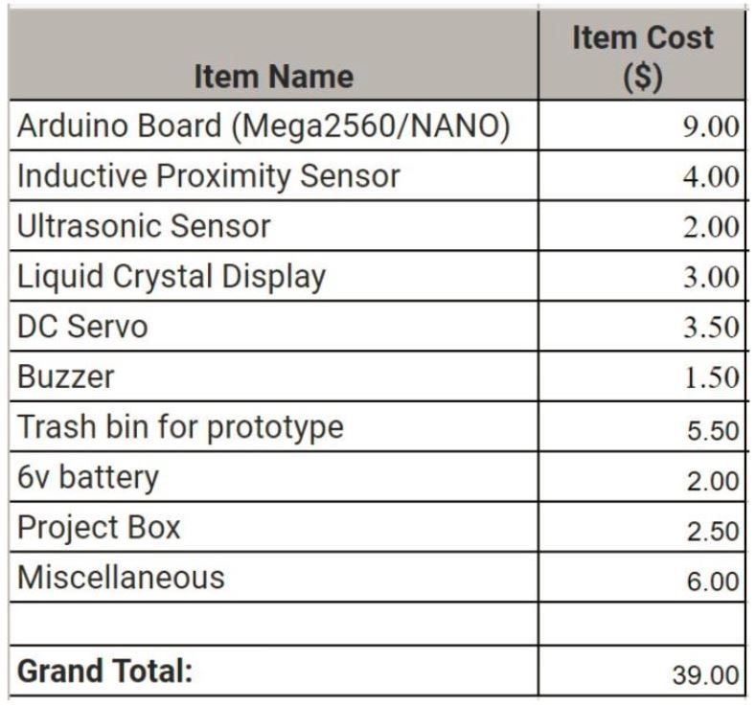

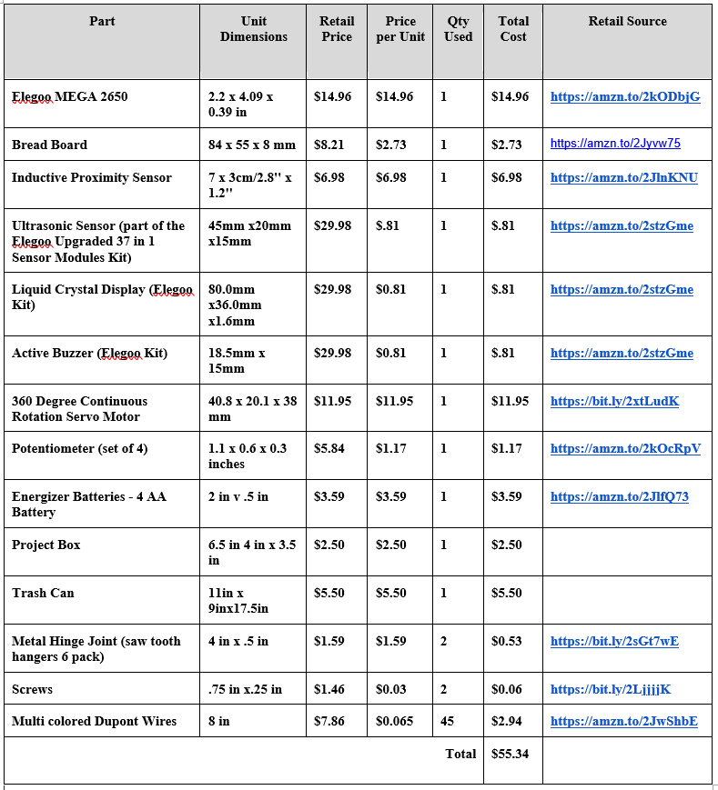

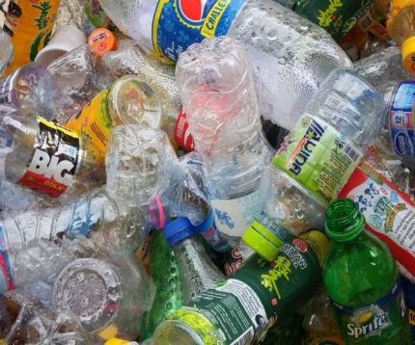 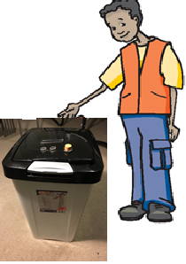 

**Reduce landfills, use R3 device, to save the environment**

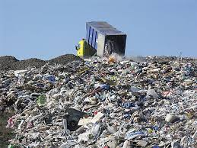

**Reduce landfills,**



**use R3 device,**



**to save the environment**

 **Graphs** 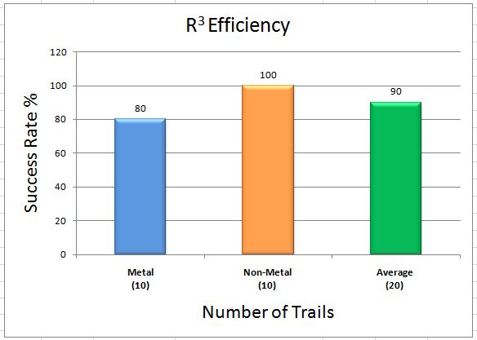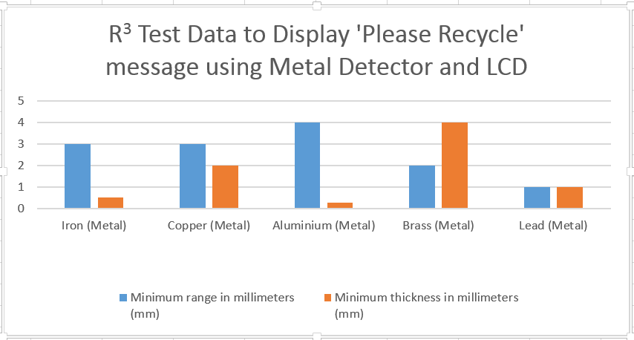 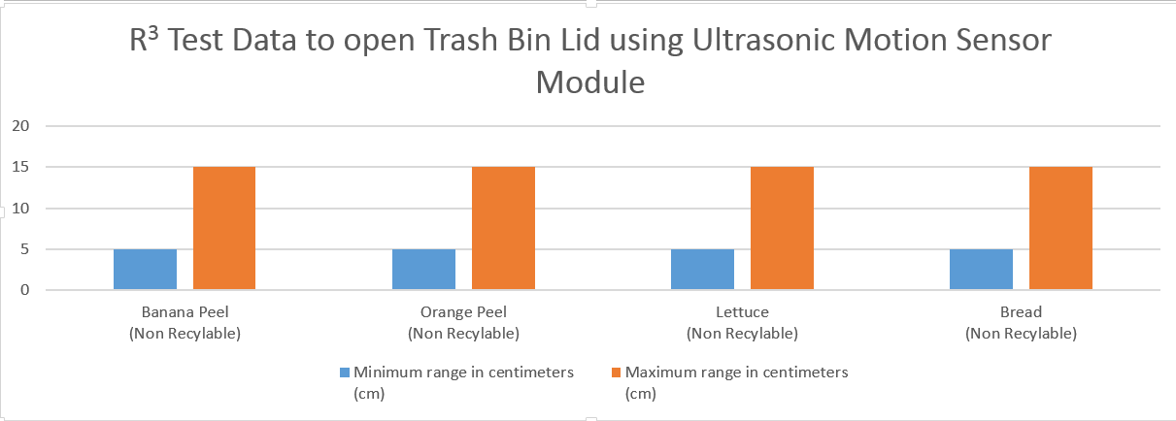

Conclusion: After conducting the design flow analysis, on three designs, we choose a device to identify recyclable items while throwing them in the trash bin with lid as best.

- Improves efficiency of recyclable items identification

- To identify metal items with LCD display panel, buzzer prompting and auto lid open/close functionality

- Can be enhanced to paper and plastic.

- Notify user's phone with recyclable data is nice to have in future.

Support material:

- For prototype layout and flow diagram, please refer to figure 1 and 2

- Arduino code reference code reference: https://github.com/theroboknoghts/r3